Climate Change Threatens the Biodiversity of the World’s Marine Protected Areas

John F. Bruno1, Amanda E. Bates2, Chris Cacciapaglia3, Elizabeth P. Pike4, Steven Amstrup5, Ruben van Hooidonk6,7, Stephanie A. Henson8, and Richard B. Aronson3

1 Department of Biology, The University of North Carolina at Chapel Hill, Chapel Hill, NC 27599-3280, USA

2 Ocean and Earth Science, National Oceanography Centre Southampton, University of Southampton, Southampton SO14 3ZH, UK

3Department of Biological Sciences, Florida Institute of Technology, 150 West University Boulevard, Melbourne, FL, USA 32901

4 Marine Conservation Institute, Seattle, WA, USA 98103

5 Polar Bears International, P.O. Box 3008, Bozeman, MT, USA 59772

6 NOAA Atlantic Oceanographic and Meteorological Laboratory, Ocean Chemistry and Ecosystems Division, 4301 Rickenbacker Causeway, Miami, FL 33149, USA

7 Cooperative Institute for Marine and Atmospheric Studies, Rosenstiel School of Marine and Atmospheric Science, University of Miami, 4600 Rickenbacker Causeway, Miami, FL 33149, USA

8 National Oceanography Centre, Southampton, SO14 3ZH, UK

**Marine Protected Areas (MPAs)—coastal and open-ocean nature preserves—are a primary management tool designed to mitigate local threats to marine biodiversity**1**. However, MPAs and the species they protect are increasingly being impacted by climate change. Here we show that under a ‘business-as-usual’ emissions scenario (RCP8.5**; ref. 2**), for which emissions continue to rise throughout this century, the mean rate of increase of annual sea-surface temperature (SST) within MPAs is 0.034 °C/year, or roughly 2.8 °C of additional warming by 2100. At mid-to-high latitudes, warming at this rate and of this magnitude is likely to alter species composition and could increase species richness as the distributions of species shift poleward**2**. In contrast, tropical MPAs are expected to lose species and habitats as thermal tolerances are exceeded**3,2**. We also calculated the “time of emergence”—the year that properties of the oceans being altered by climate change exceed their natural variability—of temperature and oxygen concentration for 309 no-take marine reserves. Under RCP 8.5, both factors “emerge” by mid-century in most reserves. Moreover, the spatial distribution of emergence is stressor-specific; rearranging MPAs to minimize exposure to one factor may well increase exposure to another. Continuing to follow this business-as-usual emissions pathway would likely disrupt the species and ecosystems currently protected within the world’s MPAs.**

Thirty years ago Peters and Darling4 warned that nature reserves were threatened by the greenhouse effect. They argued that, because of their typically small populations, greatly restricted geographic ranges, and low genetic diversities, species dependent on reserves could be especially sensitive to climate change4. There is growing evidence that Peters and Darling were correct: numerous case-studies indicate that anthropogenic climate change is already having substantial effects on populations and ecosystems otherwise protected within terrestrial and marine reserves5,6. This is particularly evident on coral reefs. For example, gradual warming over the last several decades and unusually high seawater temperatures in early 2016 caused mass coral mortality across much of the northern Great Barrier Reef7 (GBR), a UNESCO World Heritage Site and model MPA. Despite its isolation and effective protection from harvesting, pollution, and other stressors, warming radically altered the northern GBR7. This and similar case studies call into question the long-term effectiveness of MPAs in protecting their resident biotas in the face of climate change.

We asked how much MPAs can be expected to warm under the business-as-usual emissions trajectory RCP 8.5 and the RCP 4.5 mitigation scenario8, for which emissions peak around 2040 and CO2 concentration stabilizes at ~525 ppm in 2100(ref. 2). We used CMIP5 model projections to predict the 21st century rate of change of mean SST of the geographic centers of 8236 MPAs around the world (Fig. 1A). We also assessed warming rates in 309 “no-take reserves” in which fishing is banned. Under RCP 8.5 mean SSTs are predicted to increase within nearly all MPAs: the average warming rate is 0.034 °C/year (Table 1), with a maximum increase of 0.113°C/year (in northern Baffin Bay off northwest Greenland). This predicted future warming continues the trend of recent anthropogenic warming of 0.1 °C per decade9, on average, since 1960. Projected warming rates increase slightly with latitudinal zone, from the tropics to polar oceans (Table 1). Remarkably, under RCP 8.5, 99% of the world’s MPAs are forecasted to warm by ≥2°C by 2100. The RCP 4.5 mitigation scenario predicts substantially lower warming rates (Table 1), and thus presumably reduced impacts on marine organisms10,11.

The effects of ocean warming on marine species and ecosystems, which are already well-documented12, would greatly increase if the rates of warming under RCP 8.5 are realized. Several recent studies have combined projected warming, species-specific thermal tolerances, and species-distribution and -richness patterns to predict changes in species richness and composition in response to ocean warming. For example, Stuart-Smith et al.3 predicted that nearly 100% of extant species will be excluded from many tropical reef communities by 2115 under RCP 8.5. Likewise, Molinos et al.2 predicted drastic declines in the regional species pools of tropical marine communities and substantial increases in temperate communities, accompanied by changes in species composition. These responses are driven by populations tracking the geographic movement of their thermal niches by shifting their ranges, generally to higher latitudes13–15. In mid- to high-latitude ecosystems, shifts in species composition will lead to changes in species interactions and food-web dynamics, losses of foundation species such as kelps and corals, and invasions of new predators, competitors, and parasites12–14. In contrast, as tropical communities cross their thermal thresholds, the primary outcome is expected to be biodiversity loss, as there are no climate change induced-migrants to colonize from warmer regions. Thus, ocean warming will have fundamentally different impacts on the biota currently protected in tropical and temperate MPAs. Finally, due to temperature-dependent metabolism of fishes and invertebrates, which are ectotherms, warming will have strong, non-lethal effects on a wide array of population-, community-, and ecosystem-level processes including developmental and dispersal rates, species interactions, and the standing biomass of plants and animals15,16.

Not all of these effects will be realized in every reserve. For example, individuals can acclimatize to a degree, and populations can adapt to warming. However, there are limits to the scope and rate of both acclimatization and adaptation that vary with phylogenetic history, life history, and other biological attributes. Moreover, anthropogenic warming is occurring at an unprecedented rate: 10-100 times more rapidly than has occurred over the last 65 million years17. Carbon emissions are also leading to additional acute and chronic perturbations including increasing storm intensity, rising sea levels, altered upwelling regimes, ocean acidification, and deoxygenation4,10,11. As a result, organisms must simultaneously adjust their physiologies to cope with multiple threats that in some cases could be selecting for opposing traits.

Under RCP 8.5, by 2050 trends in three key ecosystem stressors (warming, declining pH, and deoxygenation) exceed background variability over 86% of the ocean4,10,11. Assuming organisms are adapted to local environmental conditions, this degree of change of multiple factors that strongly affect the metabolism and fitness of organism and partially define their fundamental niches, would likely cause local extinctions and changes in species composition. We considered this emergence point—the exceedance of natural variability—to be a loose threshold for population and community responses to climate change. We calculated the year of emergence (i.e., the timing of exceedance) of warming and deoxygenation for no-take marine reserves at different latitudes (Fig. 2). Under RCP 8.5, both stressors emerge by mid-century in xx% of no-take zones.Unlike deoxygenation (Fig. 2A), the year of emergence for temperature was later by decades for high latitude reserves (Fig. 2A, but note there is substantial variation at a given latitude). In fact, temperature has already exceeded background variability for many tropical reserves.

Warming rates are projected to be relatively modest in some ecoregions, including many around Australia and New Zealand, and more rapid in others, such as the Western Mediterranean and South Orkney Islands (Table S1). However, the substantial variation in the inherent thermal sensitivity of constituent species among ecoregions (i.e., thermal bias3), complicates predictions and comparison of regional and local warming impacts. The margin between what a species can tolerate and local maximum temperatures, averaged across all species in a community, is the “Community Thermal Safety Margin” (CTSM, Fig. 2C). Based on predicted warming under RCP 8.5, for many tropical ecoregions the CTSM will (on average) be reached by ~2050 and at temperate latitudes, not until ~2150. This means that maximum summertime temperatures will exceed the estimated tolerance for the average species within the community. In theory, this will cause the loss of a substantial number of species, even with a reasonable degree of adaptation or acclimatization (e.g., 1° C, Fig. 2C).

One potential management response to anthropogenic warming is to position reserves within regions expected to warm less or not at all, in ‘climate change refugia’18,19. However, forecasted warming rates for MPAs roughly match mean background rates, except in polar regions (Table 2). Polar MPAs are forecasted to warm far more slowly than the background rates for polar oceans. At a smaller scale, we found that there was substantial variation among ecoregions in projected warming (Table S1) but that MPA placement was not focused on ecoregions with lower rates (Fig. S2). Even if future MPAs are better positioned in regard to projected warming, the distribution of other important climate change stressors such as deoxygenation is spatially discordant with that of temperature (Fig. 3). Locations for which SST emerges after 2050 under RCP 8.5 are primarily in the Southern Ocean, whereas refugia from deoxygenation are mainly tropical (Fig. 3). Multi-factor refugia are relatively rare and have very little overlap with the current distribution of existing MPAs (Fig. SX).

Marine biodiversity is already being degraded by numerous stressors unrelated to carbon emissions such as fishing, habitat loss, and pollution. Populations of marine vertebrates, especially predators, have been reduced by 50 to 95% in most oceanic regions20, and habitat-forming species such as seagrasses, mangroves, and corals are declining by 1–2% annually21–23. Although not a panacea, well-enforced MPAs, particularly no-take marine reserves, have been shown to effectively mitigate some of these threats and partially restore marine biodiversity24,25. A recent meta-analysis found that to meet the biodiversity and fisheries goals of MPAs, global coverage needs to be increased from 3% of ocean surface area to 30% or greater26. We support the rapid expansion of fully-protected MPAs and other forms of local conservation such as marine spatial planning, with the critical caveat that local protection is necessary but insufficient to conserve and restore marine biota1. Although MPAs are widely-promoted as a means to mitigate the effects of climate change27, the opposite perspective is more in line with the scientific reality: without drastic reductions in carbon emissions, ocean warming, acidification, and oxygen depletion in the 21st century will in all likelihood disrupt the composition and functioning of the ecosystems currently protected within the world’s MPAs. This would negate decades of progress in conservation and further imperil already threatened species and ecosystems.

**Literature Cited (30 max)**

1. Allison GW, Lubchenco J, Carr MH. Marine reserves are necessary but not sufficient for marine conservation. *Ecol Appl*. 1998;8(sp1).

2. García Molinos J, Halpern BS, Schoeman DS, et al. Climate velocity and the future global redistribution of marine biodiversity. *Nat Clim Chang*. 2015;6(1):83-88. doi:10.1038/nclimate2769.

3. Stuart-Smith RD, Edgar GJ, Barrett NS, Kininmonth SJ, Bates AE. Thermal biases and vulnerability to warming in the world’s marine fauna. *Nature*. November 2015. doi:10.1038/nature16144.

4. Peters RL. The Greenhouse Effect and Nature Reserves. *Bioscience*. 1985;35(11):707-717. doi:10.2307/1310052.

5. Graham N a J, McClanahan TR, MacNeil MA, et al. Climate warming, marine protected areas and the ocean-scale integrity of coral reef ecosystems. *PLoS One*. 2008;3(8):e3039. doi:10.1371/journal.pone.0003039.

6. Monahan WB, Fisichelli NA. Climate exposure of US national parks in a new era of change. *PLoS One*. 2014;9(7):e101302.

7. Hughes TP, Kerry J, Álvarez-Noriega M, et al. Global warming and recurrent mass bleaching of corals. *Nature*. 2017. doi:10.1038/nature21707.

8. Moss RH, Edmonds JA, Hibbard KA, et al. The next generation of scenarios for climate change research and assessment. *Nature*. 2010;463(7282):747-756. http://dx.doi.org/10.1038/nature08823.

9. Burrows MT, Schoeman DS, Buckley LB, et al. The pace of shifting climate in marine and terrestrial ecosystems. *Science (80- )*. 2011;334(6056):652-655. doi:10.1126/science.1210288.

10. Gattuso J-P, Magnan A, Bille R, et al. Contrasting futures for ocean and society from different anthropogenic CO2 emissions scenarios. *Science (80- )*. 2015;349(6243):aac4722-1-aac4722-10. doi:10.1126/science.aac4722.

11. Henson SA, Beaulieu C, Ilyina T, et al. Rapid emergence of climate change in environmental drivers of marine ecosystems. *Nat Commun*. 2017;8(5020):14682. doi:10.1038/ncomms14682.

12. Poloczanska ES, Brown CJ, Sydeman WJ, et al. Global imprint of climate change on marine life. *Nat Clim Chang*. 2013;3(10):919-925. doi:10.1038/nclimate1958.

13. Aronson RB, Thatje S, Clarke A, et al. Climate Change and Invasibility of the Antarctic Benthos. *Annu Rev Ecol Evol Syst*. 2007;38(1):129-154. doi:10.1146/annurev.ecolsys.38.091206.095525.

14. Burrows MT, Schoeman DS, Buckley LB, et al. The Pace of Shifting Climate in Marine and Terrestrial Ecosystems. *Science (80- )*. 2011;334(6056):652-655. doi:10.1126/science.1210288.

15. Bruno JF, Carr LA, O’Connor MI. Exploring the role of temperature in the ocean through metabolic scaling. *Ecology*. 2015;96(12):3126-3140. doi:10.1890/14-1954.1.

16. Svensson F, Karlsson E, G\a ardmark A, et al. In situ warming strengthens trophic cascades in a coastal food web. *Oikos*. 2017:In press.

17. Diffenbaugh NS, Field CB. Changes in Ecologically Critical Terrestrial Climate Conditions. *Science (80- )*. 2013;341(6145):486. doi:10.1126/science.1237123.

18. Cacciapaglia C, van Woesik R. Reef-coral refugia in a rapidly changing ocean. *Glob Chang Biol*. 2015;21(6):2272-2282. doi:10.1111/gcb.12851.

19. McLeod E, Salm R, Green A, Almany J. Designing marine protected area networks to address the impacts of climate change. *Front Ecol Environ*. 2009;7(7):362-370. doi:10.1890/070211.

20. McCauley DJ, Pinsky ML, Palumbi SR, Estes J a., Joyce FH, Warner RR. Marine defaunation: Animal loss in the global ocean. *Science (80- )*. 2015;347:247-254. doi:10.1126/science.1255641.

21. Waycott M, Duarte CM, Carruthers TJB, et al. Accelerating loss of seagrasses across the globe threatens coastal ecosystems. *Proc Natl Acad Sci*. 2009;106:12377-12381. doi:10.1073/pnas.0905620106.

22. Polidoro BA, Carpenter KE, Collins L, et al. The loss of species: Mangrove extinction risk and geographic areas of global concern. Hansen DM, ed. *PLoS One*. 2010;5(4):e10095. doi:10.1371/journal.pone.0010095.

23. Bruno JF, Selig ER. Regional decline of coral cover in the Indo-Pacific: timing, extent, and subregional comparisons. *PLoS One*. 2007:e711.

24. Edgar GJ, Stuart-Smith RD, Willis TJ, et al. Global conservation outcomes depend on marine protected areas with five key features. *Nature*. 2014;506(7487):216-220. doi:10.1038/nature13022.

25. Lester SE, Halpern BS, Grorud-Colvert K, et al. Biological effects within no-take marine reserves: A global synthesis. *Mar Ecol Prog Ser*. 2009;384:33-46. doi:10.3354/meps08029.

26. O’Leary BC, Winther-Janson M, Bainbridge JM, Aitken J, Hawkins JP, Roberts CM. Effective coverage targets for ocean protection. *Conserv Lett*. 2016;9(6):398-404. doi:10.1111/conl.12247.

27. Roberts CM, O’Leary BC, McCauley DJ, et al. Marine reserves can mitigate and promote adaptation to climate change. *Proc Natl Acad Sci* . 2017;114(24):6167-6175. doi:10.1073/pnas.1701262114.

**Table 1.** Projected rates of increase of ocean temperature (mean SST °C / year ± 1 SD) in no-take marine reserves and for MPAs in four latitudinal zones for two different emission scenarios (RCP 8.5 and 4.5) based on CMIP5 simulation ensembles. what’s the time period this is calculated? 2001-2100??

|  |  |  |  |  |  |  |  |
| --- | --- | --- | --- | --- | --- | --- | --- |
| Metric | Model | Reserves  (309) | All MPAs  (8236) | Tropical  (2458) | Subropical  (2738) | Temperate  (2738) | Polar  (166) |
| Mean | 8.5 | 0.033±0.004 | 0.034± 0.006 | 0.032±0.002 | 0.034±0.004 | 0.036±0.007 | 0.038±0.013 |
| Mean | 4.5 | 0.014±0.002 | 0.015±0.003 | 0.014±0.001 | 0.015±0.002 | 0.016±0.004 | 0.019±0.009 |
| Max | 8.5 | 0.035±0.006 | 0.037±0.007 | 0.033±0.002 | 0.037±0.006 | 0.042±0.007 | 0.043±0.011 |
| Max | 4.5 | 0.015±0.003 | 0.016±0.003 | 0.014±0.001 | 0.016±0.003 | 0.018±0.004 | 0.021±0.004 |

**Table 2** Projected rates of increase (mean values and sample size = number of SIZE (in km) cells) of ocean temperatures in MPAs and for entire latitudinal zones (all cells) for RCP 8.5. Overall mean rate of the global ocean is 0.042 (n=44012 cells).

|  |  |  |  |  |
| --- | --- | --- | --- | --- |
|  | Tropical | Subropical | Temperate | Polar |
| MPAs only | 0.032 (2458) | 0.034 (2738) | 0.036 (2738) | 0.038 (166) |
| Entire region | 0.032 (13289) | 0.031 (8433) | 0.032 (13352) | 0.081 (8938) |

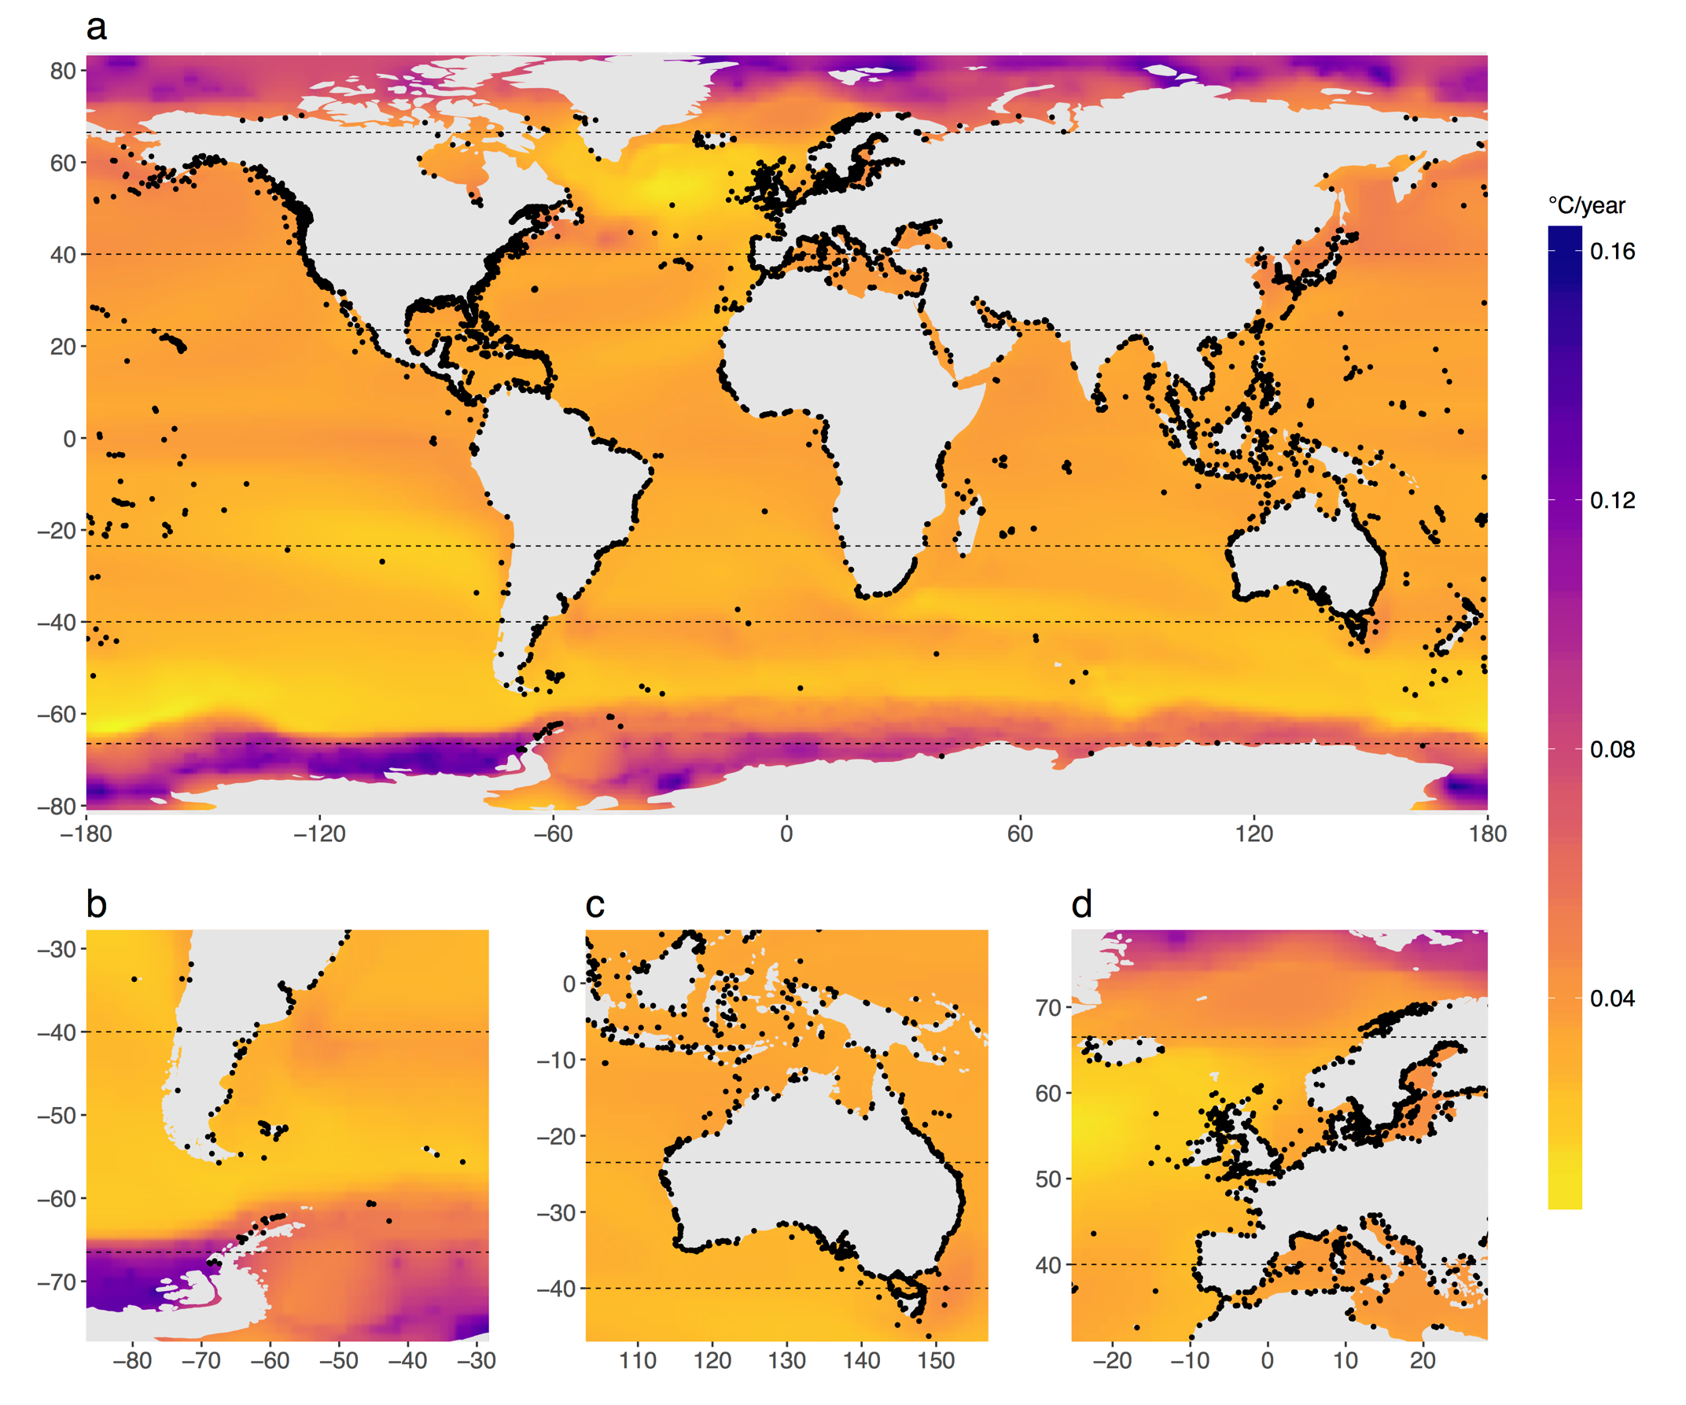

**Figure 1. Patterns of projected ocean warming.** Rates (°C/year) are based on CMIP5 ensemble model under the RCP 8.5 emissions scenario over 2001-2100????. Black dots are MPAs used in the study.

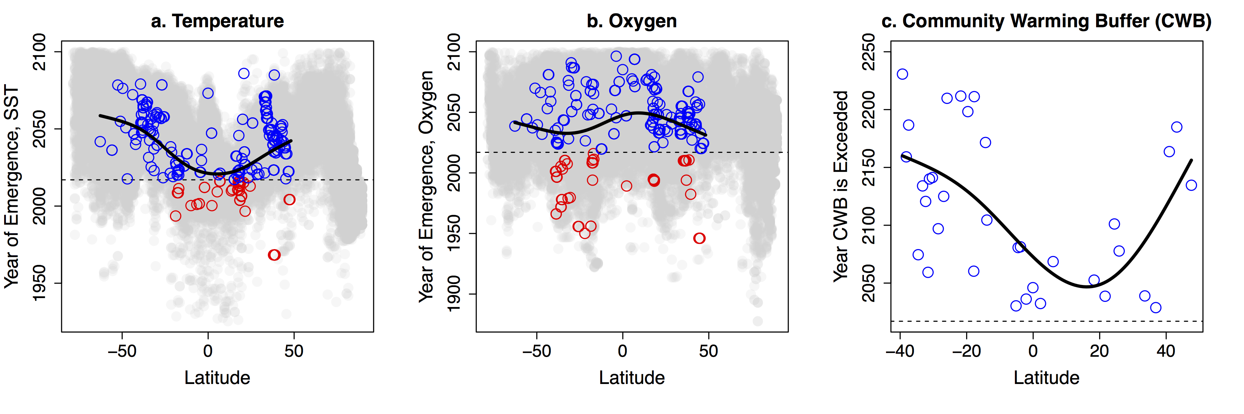

**Figure 2.** **Latitudinal patterns of the year that environmental conditions in fully protected marine reserves will exceed predicted thresholds.** For A & B: Blue circles are reserves in which thresholds have already been exceeded (in 2017), red circles are reserves that have not, and grey circles are grid cells not in a marine reserve. Black lines are fitted functions from a GAM model that includes a spatial autocorrelation term. C: Predicted community safety margins for marine ecoregions based on the predicted mean warming rate (RCP 8.5) for all MPAs in each ecoregion (see values in Table S1). The Community Mean Warming Buffer is the average maximum temperature across the geographical ranges (determined with 2,447 *in situ* surveys by the Reef Life Survey (RLS) program3) of all species in a community minus the present maximum summertime SST; it is an estimate of how far on average community inhabitants are from their thermal maxima3. Although the predicted latitudinal pattern of the year of emergence for temperature (Fig. 2A) roughly matches the geographic pattern for the CMWB, the latter pattern is largely driven by the inherent differences among latitudes in the CMWB3 (Fig. S3).

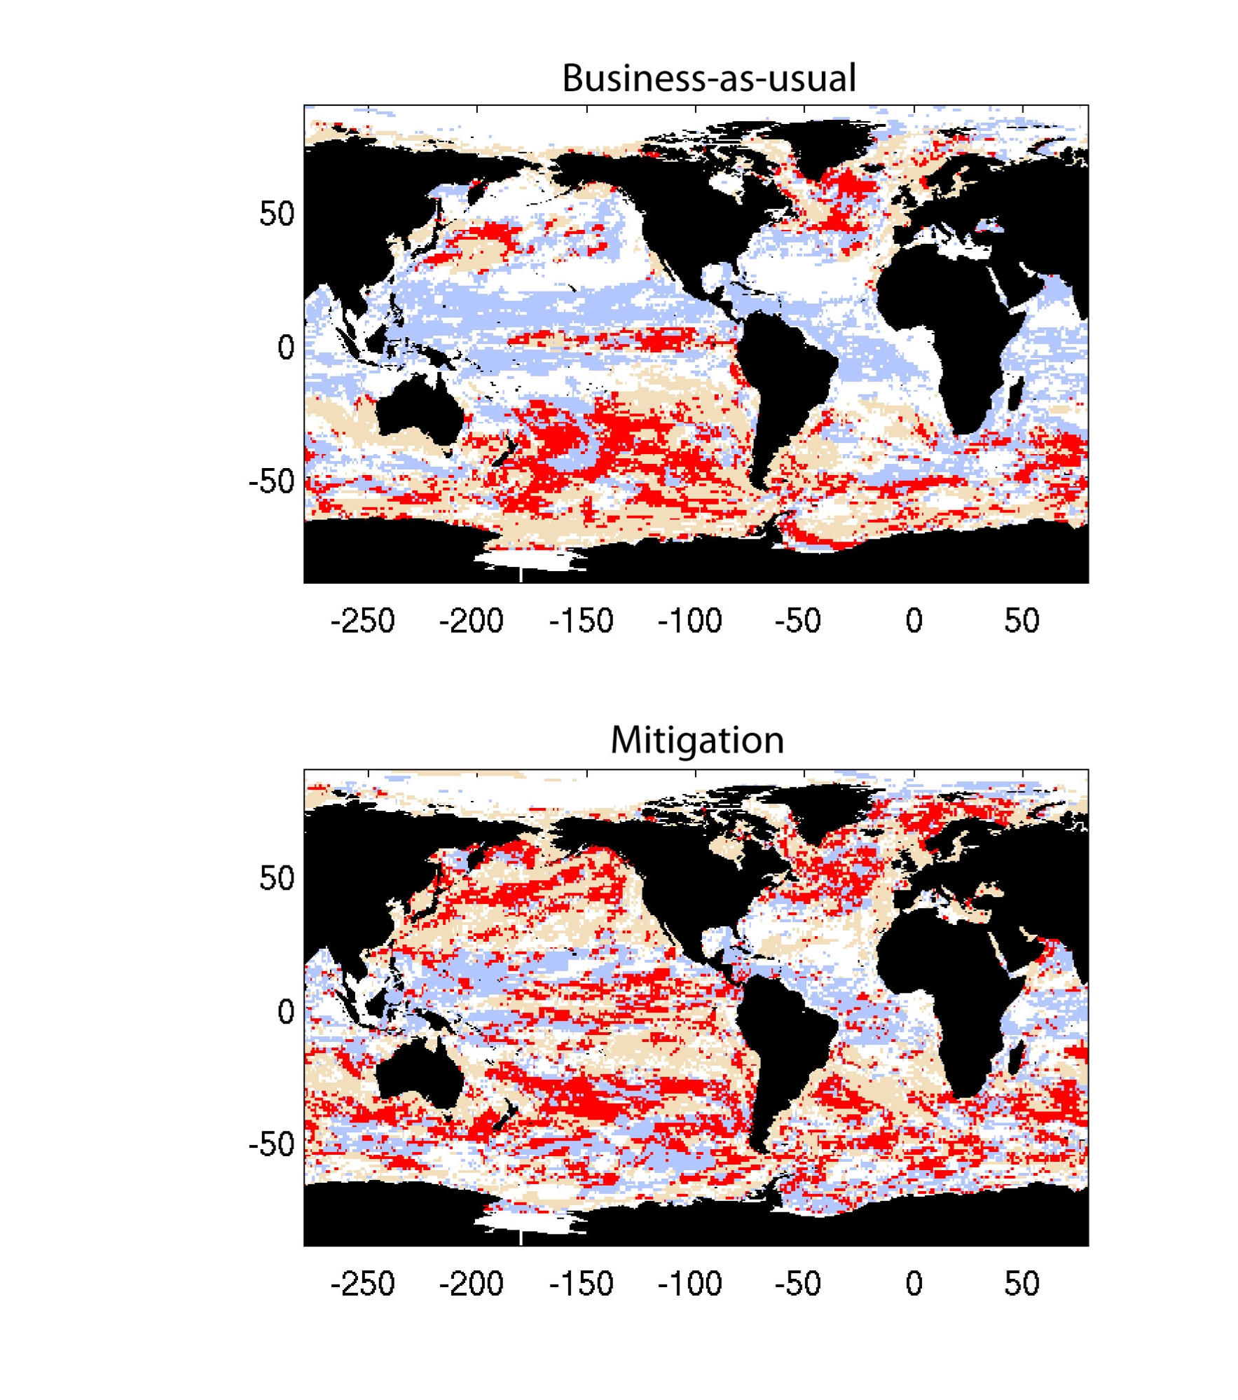

**Figure 3. Spatial distribution of temporary refugia from climate change in the ocean.** Areas of the ocean for which SST (orange), oxygen concentration (lilac), and both factors (red) emerge after 2050 for RCP 8.5 (top panel) and 4.5 (bottom panel). The ocean surface area covered by RCP 4.5 multifactor refugia (46 x e6 km2) is nearly twice the size of that of RCP 8.5 (79 x e6 km2).

**Methods Text.** xxx

Sea Surface Temperature (SST) data were collated from CMIP5 climate ensembles for both RCP4.5 wm-2 and RCP8.5 wm-2 (ESM2M or ESM2G? where did this trend data come from "trend_yearmean_ensemble_tos_RCP85.nc”? It was while we were looking at the downscaled data from Ruben but I can’t find a directory to a site for info - Feb 6th – 21st email string) at a spatial resolution of 1x1 degree as well as at a downscaled <5km scale. The 1x1 degree data ranged from 90oN to 90oS whereas the downscaled data ranged from 45oN to 45oS. These data were saved as raster files and imported into R Studio (R Core Team 2015) using the R package ‘*raster’* (Hijmans & van Etten, 2014).

The downscaling procedure for CMIP5 data was done by R. van Hooidonk more downscaling info? I’m not sure where to find a summary of his methods in downscaling. Because of the geographic restriction of the downscaled data, it was used to validate the use of 1x1 degree resolution data for the analysis. This was done by comparing extracted values at the MPA coordinates between the two datasets within the overlapping geographic extent and testing for bias along a latitudinal gradient. And…..did it work?

The future climate scenarios (RCP4.5 and RCP8.5) were collected as both the mean and maximum rate of change between current temperatures (2006) and predicted 2100 temperatures.

Coordinates and information for Marine Protected Areas (MPAs) in the world’s oceans were gathered from?. Climatic data were extracted from the raster cell closest to the centroid of the spatial polygon for each MPA, and the distance between the raster value and centroid was measured. A downscaled SST raster from Bio-ORACLE (tyberghein et al. 2012) was used as a land mask for the CMIP5 ensemble data to filter out unwanted MPA coordinates. To prevent the analysis from including both freshwater MPAs, such as ones in the Great Lakes, and MPAs with incorrectly labelled coordinates, extracted cells greater than 50 km away from the MPA centroid were removed from the analysis.

The extracted temperature data were then stratified into four groups: 1) polar, ranging from 66.5° to 90° latitude (n=166); 2) temperate, ranging from 40° to 66.5° latitude (n=2738); 3) subtropical, ranging from 23.5° to 40° latitude (n=2738); and tropical ranging from -23.5 oS to 23.5 oN across the equator (n=2458). All analyses were also run as a global composition of MPAs (n=8236) as well as the smaller subset of no-take reserves (n=309). These groups were analyzed for both RCP 8.5 and RCP 4.5 climate scenarios. The rate of change in SST at the sites of MPAs was compared to the background rate of change. This comparison was done for each of the four geographic strata and globally.

R Core Team (2015). R: A language and environment for statistical computing. R Foundation for Statistical Computing, Vienna, Austria. URL https://www.R-project.org/.

Robert J. Hijmans (2015). raster: Geographic Data Analysis and Modeling. R package version 2.4-20. http://CRAN.R-project.org/package=raster

Tyberghein L, Verbruggen H, Pauly K, Troupin C, Mineur F, De Clerck O (2012) Bio-ORACLE: a global environmental dataset for marine species distribution modelling. Global Ecology and Biogeography, 21, 272–281.

If you are running short on references the raster package citation can typically be removed with the removal of using the R package ‘*raster’* (Hijmans & van Etten, 2014) without being innacurate. You can possibly remove the CRAN citation and referencing that you did work in R as well, but maybe in sups if you include your code.

Also a comment on “The exception is Polar MPAs, for which the rate is far lower than the forecasted background rate of polar oceans.” – this is probably fine because you don’t actually run a statistical test, but you may get comments about autocorrelation in these comparisons. I think a good rebuttal or a reason not to include autocorrelation is that one of highlights of this experiment is that many MPS’s are autocorrelated because of the biases that go into choosing their locations and we don’t want to ignore that bias.

Another comment on using all cells in the region, I think it should be annotated “N=44012” instead of “n=44012” because it is the complete population of cells, not just a sample.

**Table S1.** Meanprojected warming rates (SST °C / year) of MPAs in different marine ecoregions under the RCP 8.5 scenario, based on CMIP5 simulation ensembles. N=number of MPAs per ecoregion.

|  |  |  |
| --- | --- | --- |
| Ecoregion | Rate | N |
| Adriatic Sea | 0.042 | 2 |
| Bassian | 0.033 | 17 |
| Bismarck Sea | 0.032 | 3 |
| Bounty and Antipodes Islands | 0.028 | 2 |
| Campbell Island | 0.023 | 1 |
| Cape Howe | 0.031 | 8 |
| Carolinian | 0.032 | 3 |
| Central New Zealand | 0.033 | 1 |
| Chagos | 0.033 | 1 |
| Coral Sea | 0.030 | 4 |
| Cortezian | 0.033 | 2 |
| East Caroline Islands | 0.035 | 8 |
| Easter Island | 0.030 | 1 |
| Eastern Caribbean | 0.032 | 5 |
| Eastern Galapagos Islands | 0.032 | 1 |
| Exmouth to Broome | 0.028 | 5 |
| Fernando de Naronha and Atoll das Rocas | 0.031 | 1 |
| Fiji Islands | 0.030 | 9 |
| Floridian | 0.031 | 1 |
| Great Australian Bight | 0.029 | 1 |
| Greater Antilles | 0.031 | 26 |
| Gulf of Maine/Bay of Fundy | 0.035 | 2 |
| Hawaii | 0.031 | 16 |
| Houtman | 0.027 | 2 |
| Leeuwin | 0.027 | 1 |
| Line Islands | 0.031 | 2 |
| Lord Howe and Norfolk Islands | 0.025 | 3 |
| Macquarie Island | 0.024 | 2 |
| Manning-Hawkesbury | 0.027 | 4 |
| Mariana Islands | 0.030 | 7 |
| Marshall Islands | 0.032 | 1 |
| Natal | 0.031 | 1 |
| Ningaloo | 0.029 | 1 |
| Northern California | 0.036 | 42 |
| Northern Gulf of Mexico | 0.032 | 1 |
| Oregon, Washington, Vancouver Coast and Shelf | 0.037 | 12 |
| Papua | 0.030 | 1 |
| Phoenix/Tokelau/Northern Cook Islands | 0.036 | 1 |
| Prince Edward Islands | 0.024 | 1 |
| Puget Trough/Georgia Basin | 0.035 | 13 |
| Saharan Upwelling | 0.033 | 1 |
| Sahelian Upwelling | 0.033 | 1 |
| Samoa Islands | 0.033 | 3 |
| Seychelles | 0.034 | 3 |
| Shark Bay | 0.029 | 3 |
| Solomon Sea | 0.031 | 1 |
| South Australian Gulfs | 0.027 | 8 |
| South European Atlantic Shelf | 0.042 | 1 |
| South Orkney Islands | 0.057 | 1 |
| Southern California Bight | 0.034 | 20 |
| Southern Cook/Austral Islands | 0.028 | 4 |
| Southern Gulf of Mexico | 0.032 | 1 |
| Tweed-Moreton | 0.026 | 6 |
| Virginian | 0.034 | 7 |
| Western and Northern Madagascar | 0.024 | 1 |
| Western Bassian | 0.032 | 8 |
| Western Caribbean | 0.033 | 9 |
| Western Mediterranean | 0.042 | 11 |
| Western Sumatra | 0.035 | 1 |

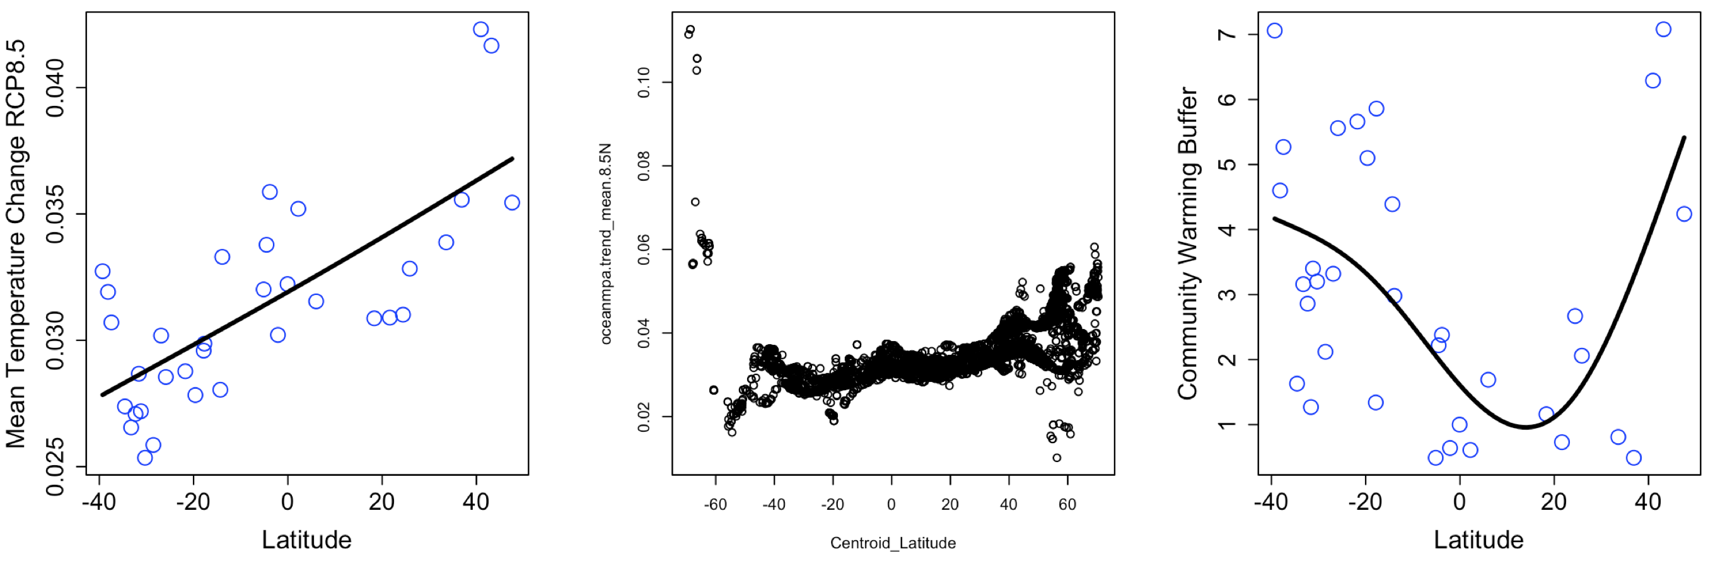

**Figure S1.** xxxx

**Figure S2.**

*Using the 41 largest MPAs (the others were far smaller than the 1x1-degree grid size of the CMIP5 model output), under RCP8.5 conditions ~ 2.5% of MPA surface area falls within the multifactor refugia.  For RCP4.5, ~ 16.5% of MPA surface area falls within the multifactor refugia.*